BOX PLOT BETWEEN FIT AND PRODUCT SIZE:

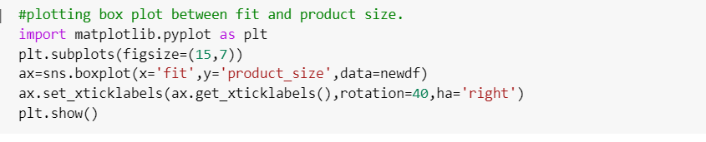

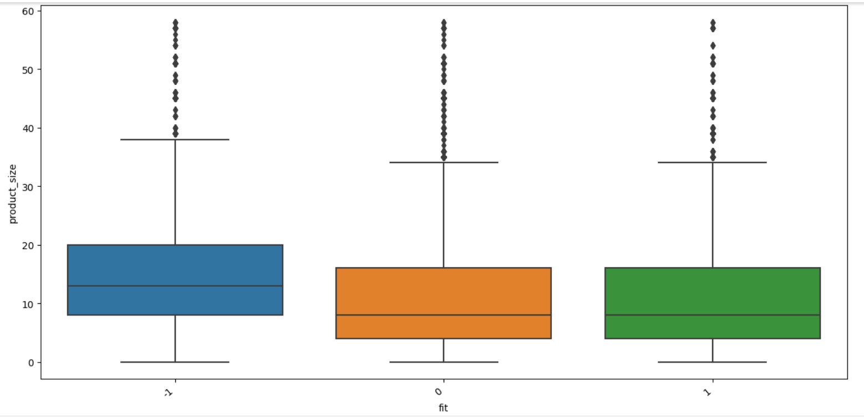

PLOTTING HISTOGRAM BETWEEN FIT AND PRODUCT SIZE:

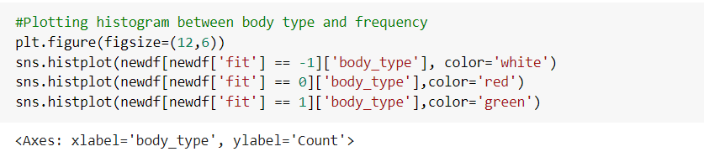

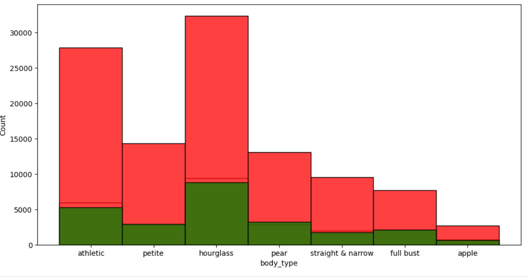

BOX PLOT BETWEEN NUMERICAL FEATURES:

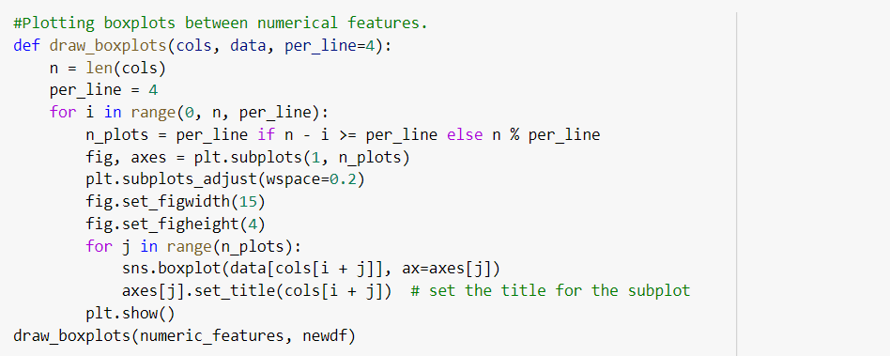

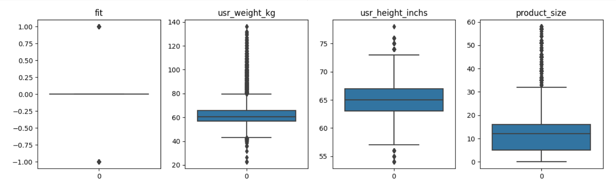

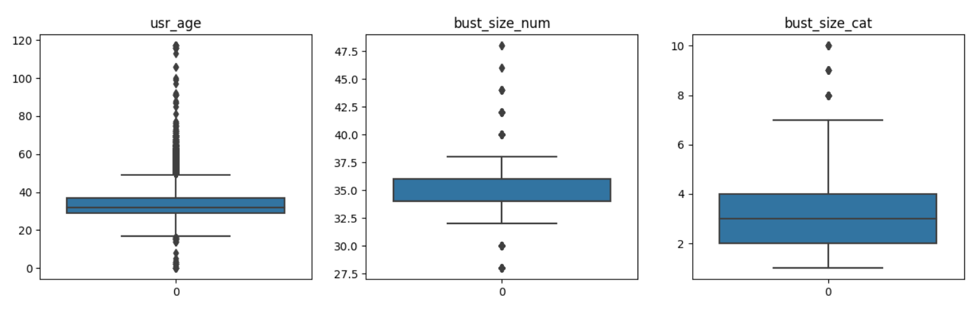

CORRELATION MATRIX:

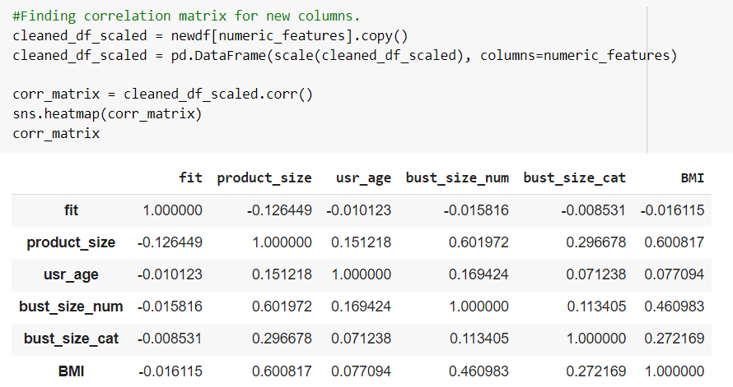

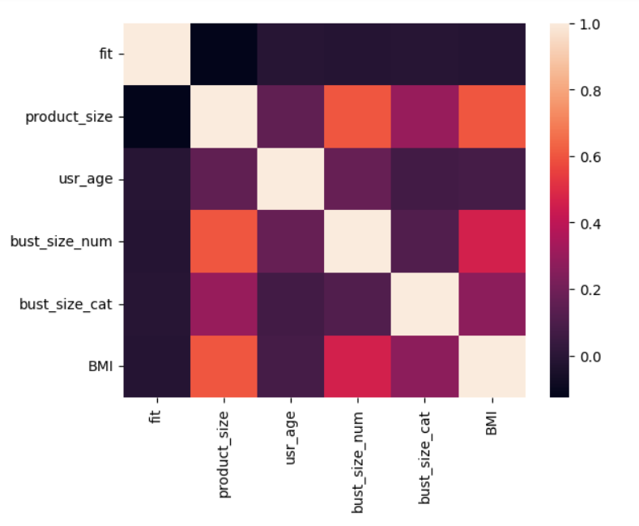

RFC BEFORE:

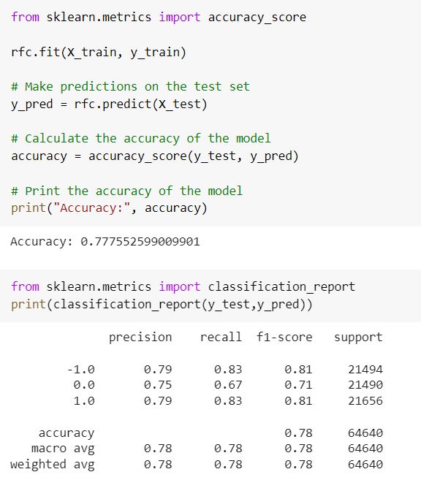

AFTER:

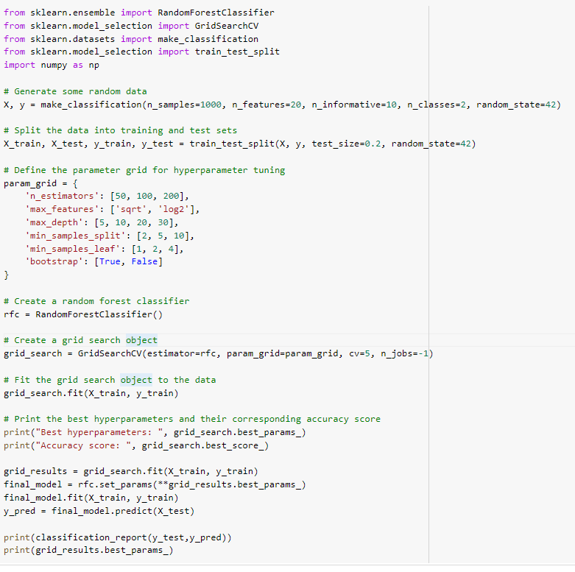

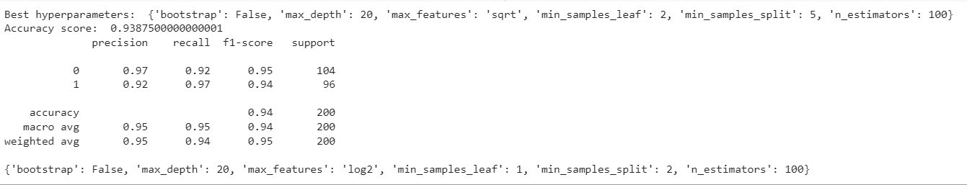

KNN AFTER:

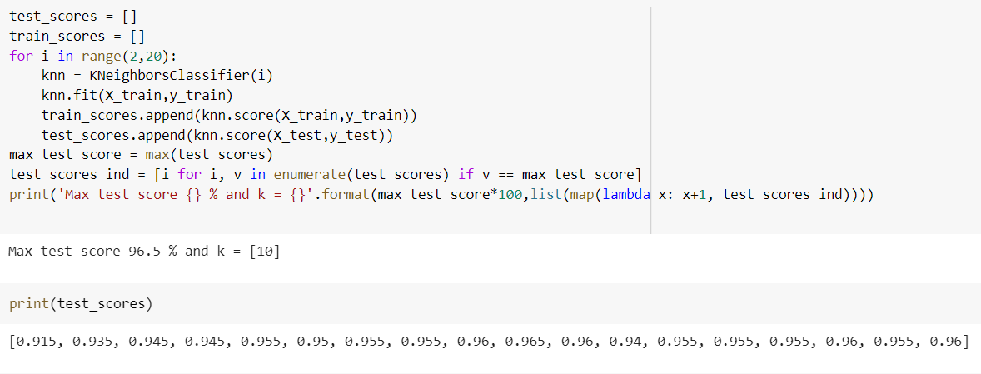

KNN GRAPH:

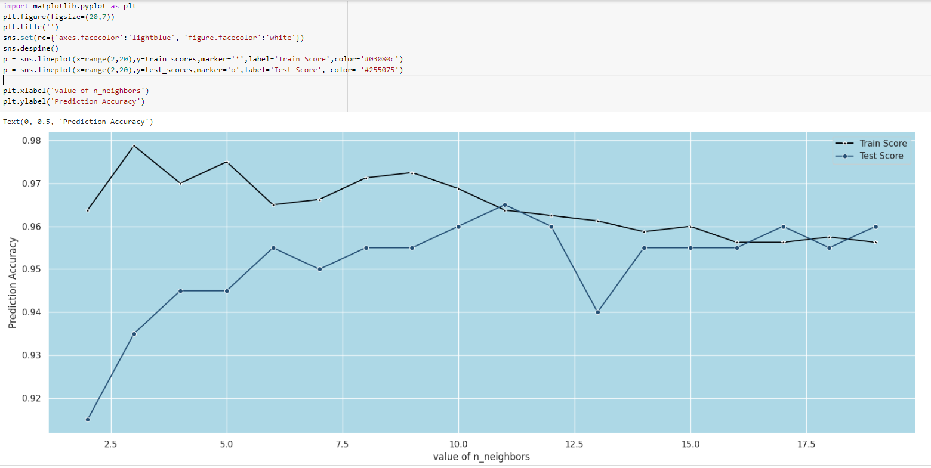

AFTER GRIDSEARCH:

